**Portfolio: Visual Art**

[click each to see big images]

**Calligraphy Exhibits and Painting Awards, 1989-present**

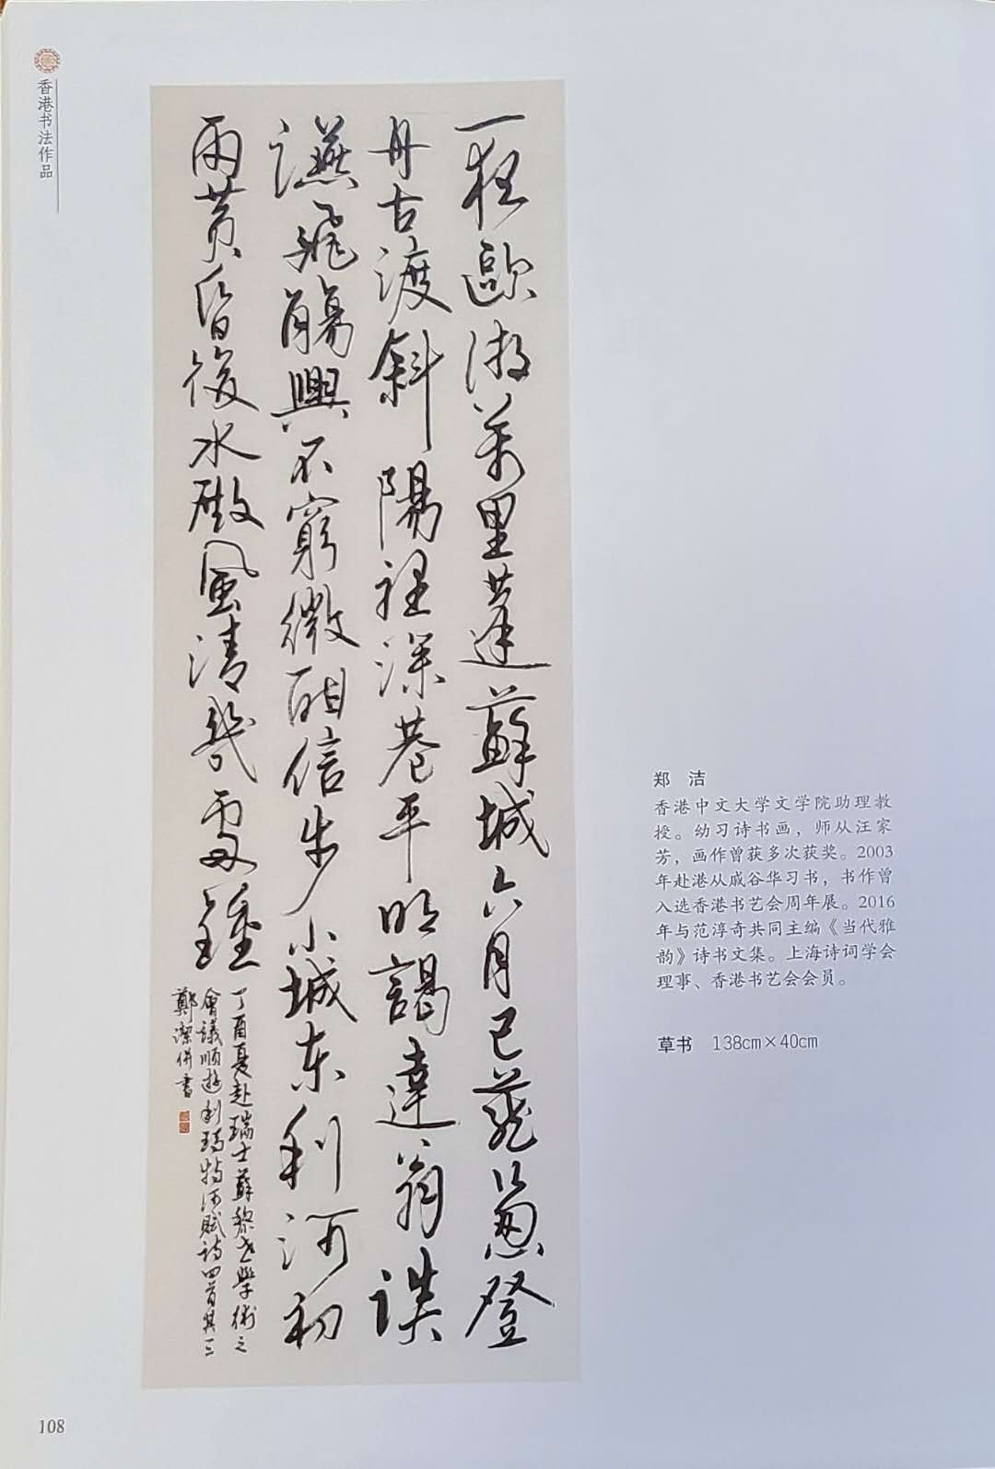 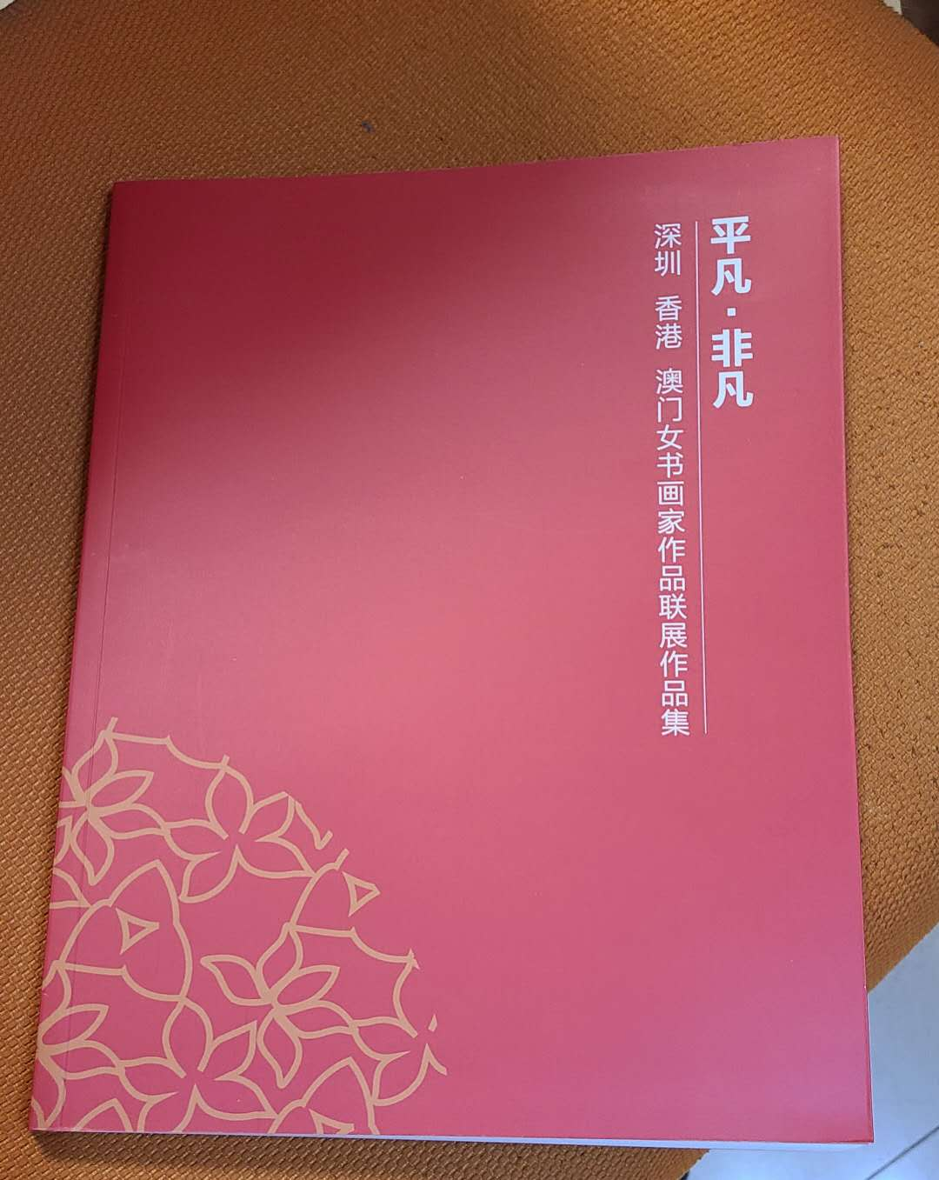

|  |  |
| --- | --- |
| 2017 | Poem and calligraphy, exhibited at the Shenzhen-Hong Kong-Macau-Guangzhou Female Artists’ Calligraphy Works, in Shenzhen. |

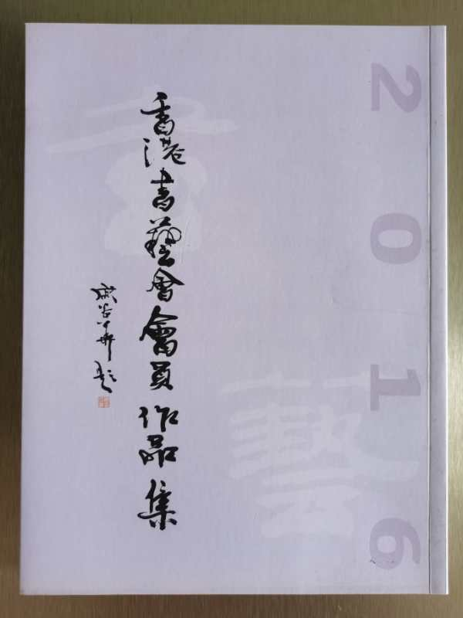

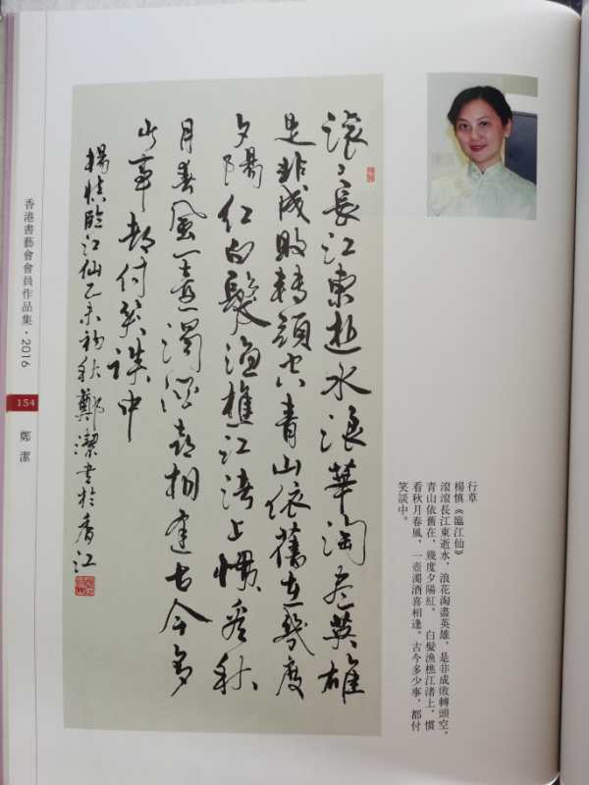

|  |  |
| --- | --- |
| 2016 | Calligraphy, exhibited at the 22nd Anniversary Exhibition of the Hong Kong Calligraphy Association, published in the catalogue. Hong Kong: Hong Kong Calligraphy Association. |

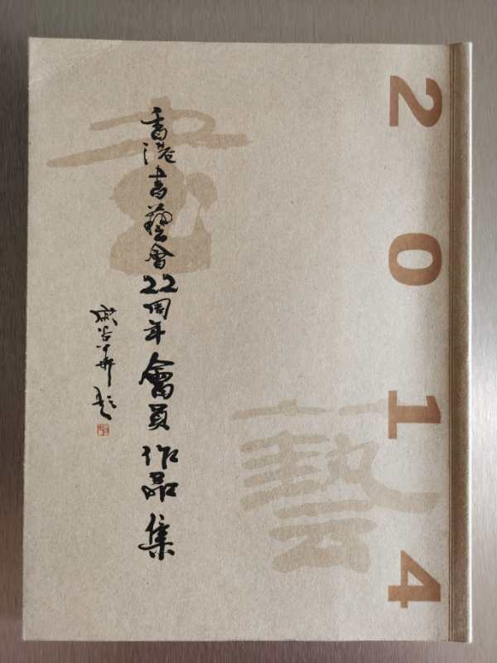

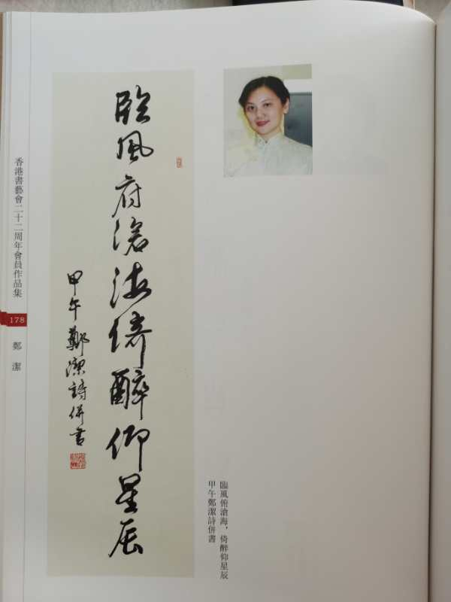

|  |  |
| --- | --- |
| 2014 | Poem and calligraphy, exhibited at the 21st anniversary exhibition of the Hong Kong Calligraphy Association, published in the catalogue. Hong Kong: Hong Kong Calligraphy Association. |

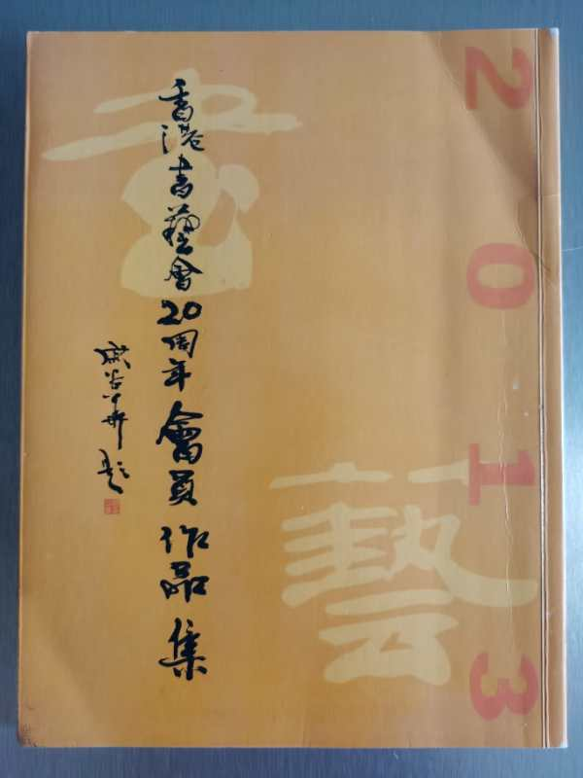

|  |  |
| --- | --- |
| 2013 | Poem and calligraphy, exhibited at the 20th anniversary exhibition of the Hong Kong Calligraphy Association, published in the catalogue. Hong Kong: Hong Kong Calligraphy Association. |

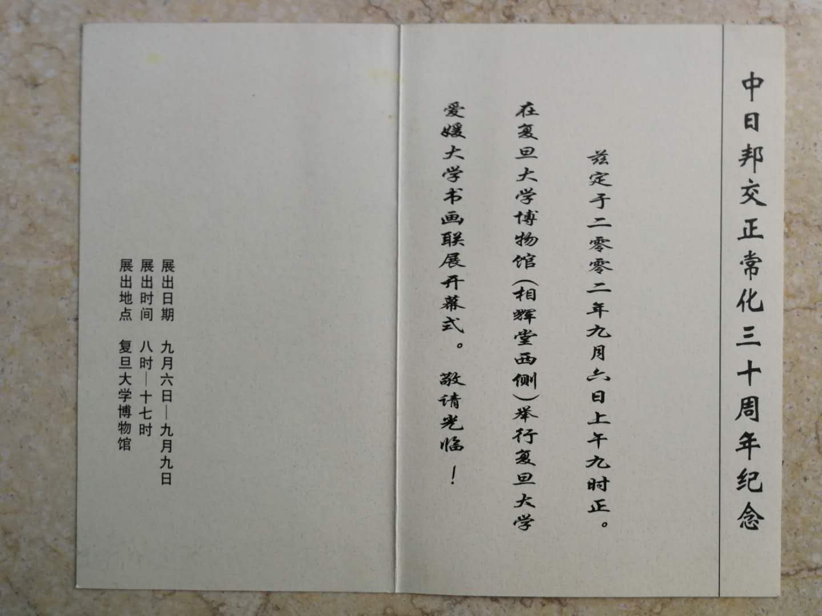

|  |  |
| --- | --- |
| 2002 | Exhibited in the “Fudan University and Ehime ken University (Japan) Interschool Painting Exhibition.” |

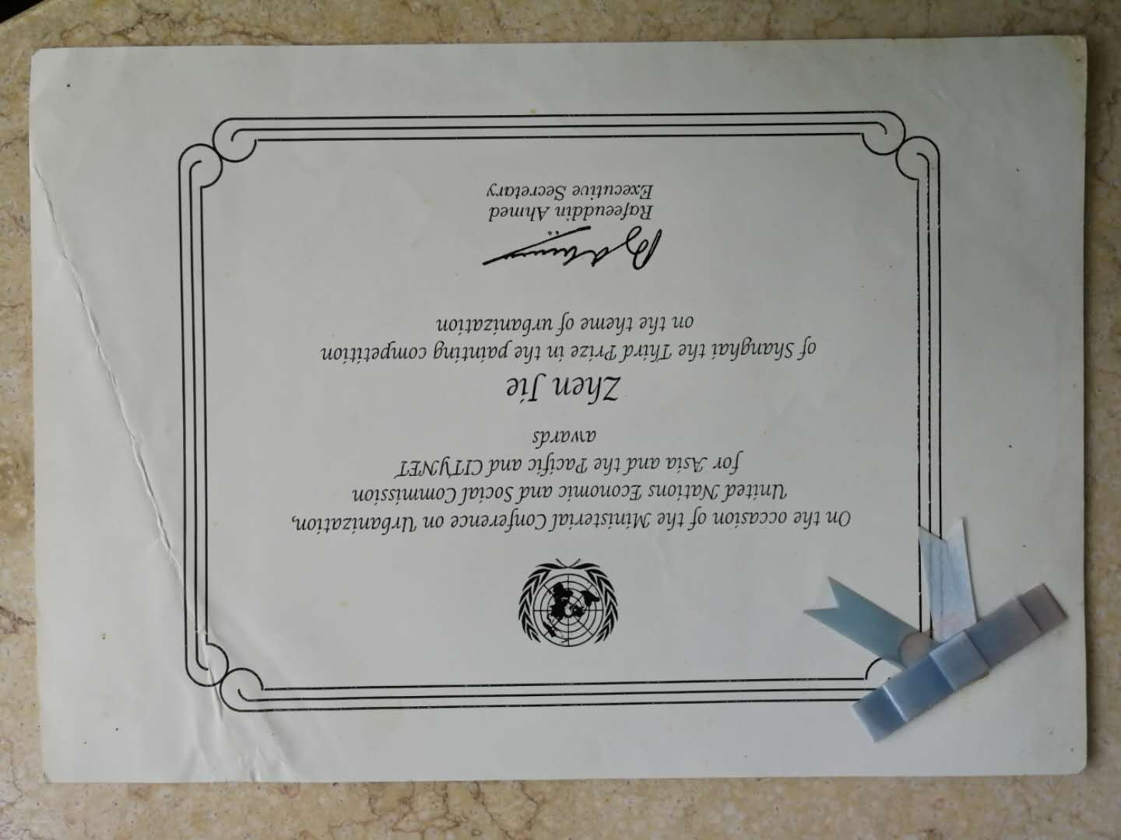

|  |  |
| --- | --- |
| 1996 | Third Prize in the “Painting Competition on Urbanization in Asia Ministerial Conference,” United Nations and the Pacific and CITNET, Thailand. |

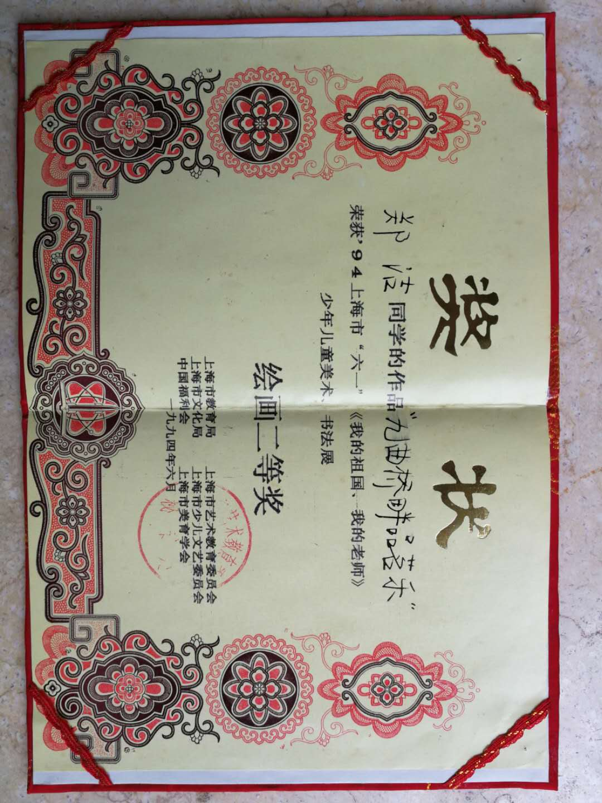

|  |  |
| --- | --- |
| 1994 | Second Prize in the painting contest themed on ‘My Motherland, My Teacher,’ Shanghai. |

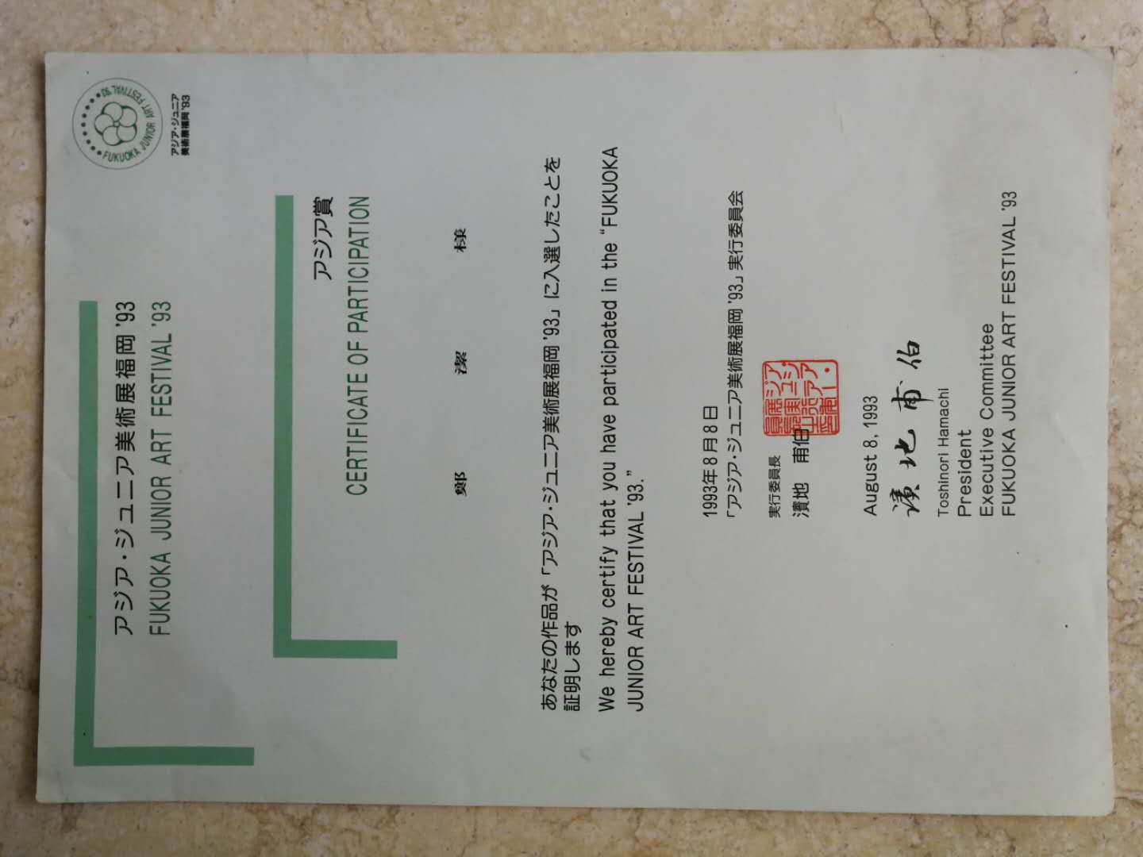

|  |  |
| --- | --- |
| 1993 | Exhibited in the FUKUOKA Junior Art Festival, Tokyo. |

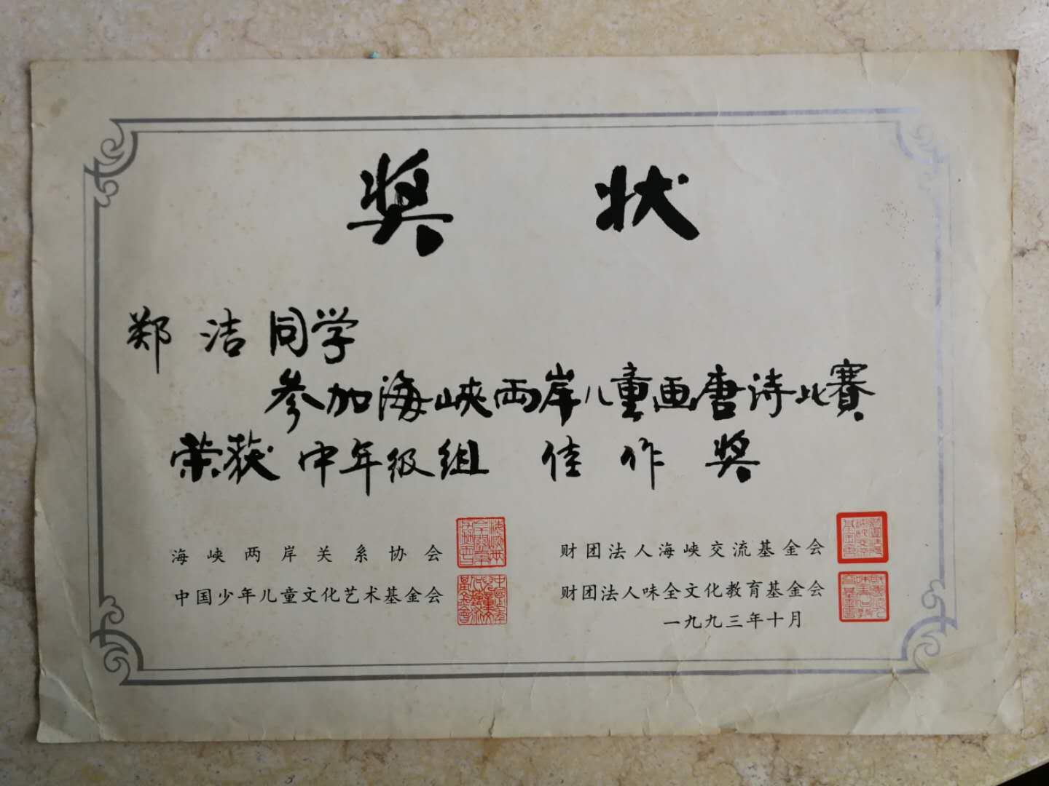

|  |  |
| --- | --- |
| 1993 | Excellent Painting Award in the Painting Tang Dynasty Poetry Contest across the Strait |

|  |  |
| --- | --- |
| 1993 | Exhibited in the Snxin Province Junior Art Festival, Snxin Province, Japan. |

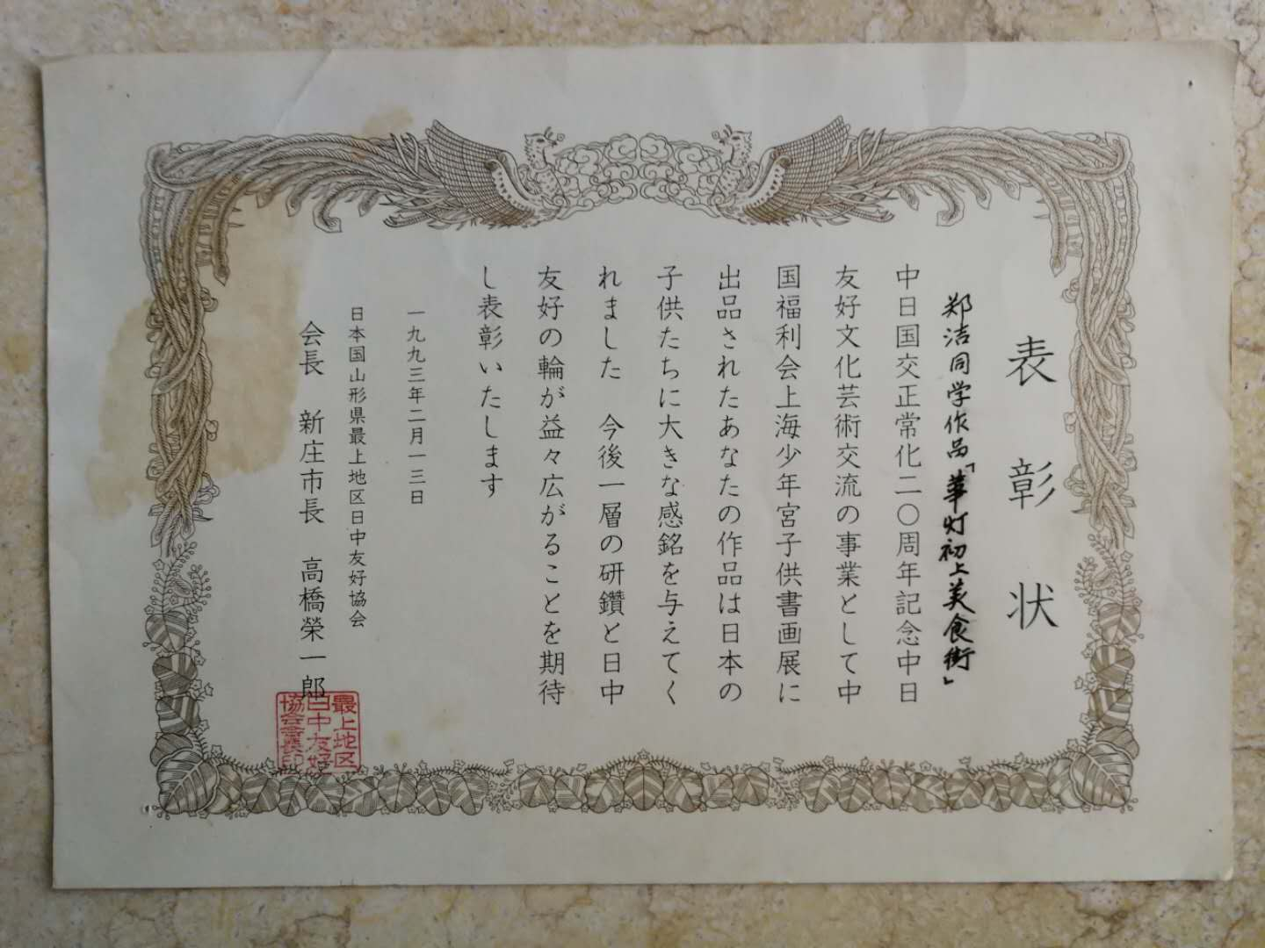

|  |  |
| --- | --- |
| 1992 | First Prize in the “Shanghai Art Cup” Art Student Painting Contest, Shanghai |

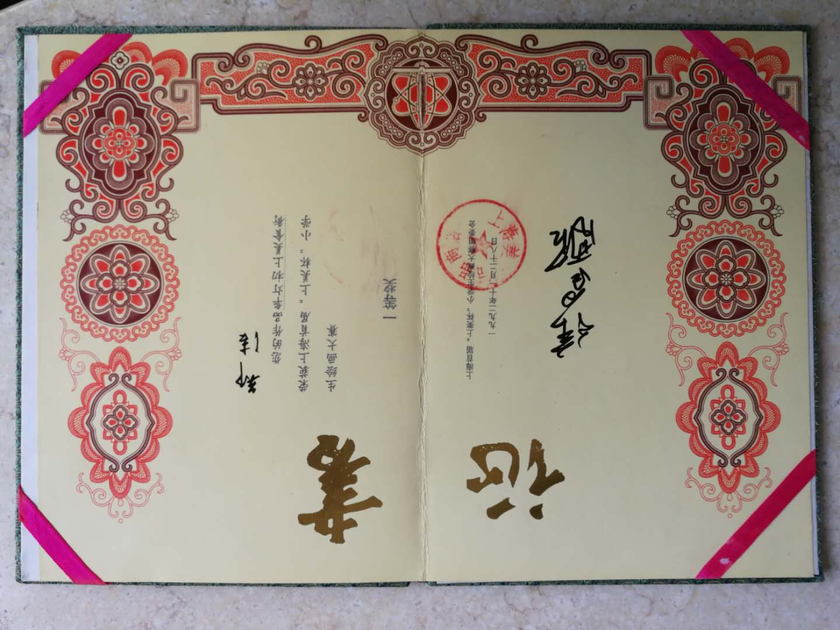

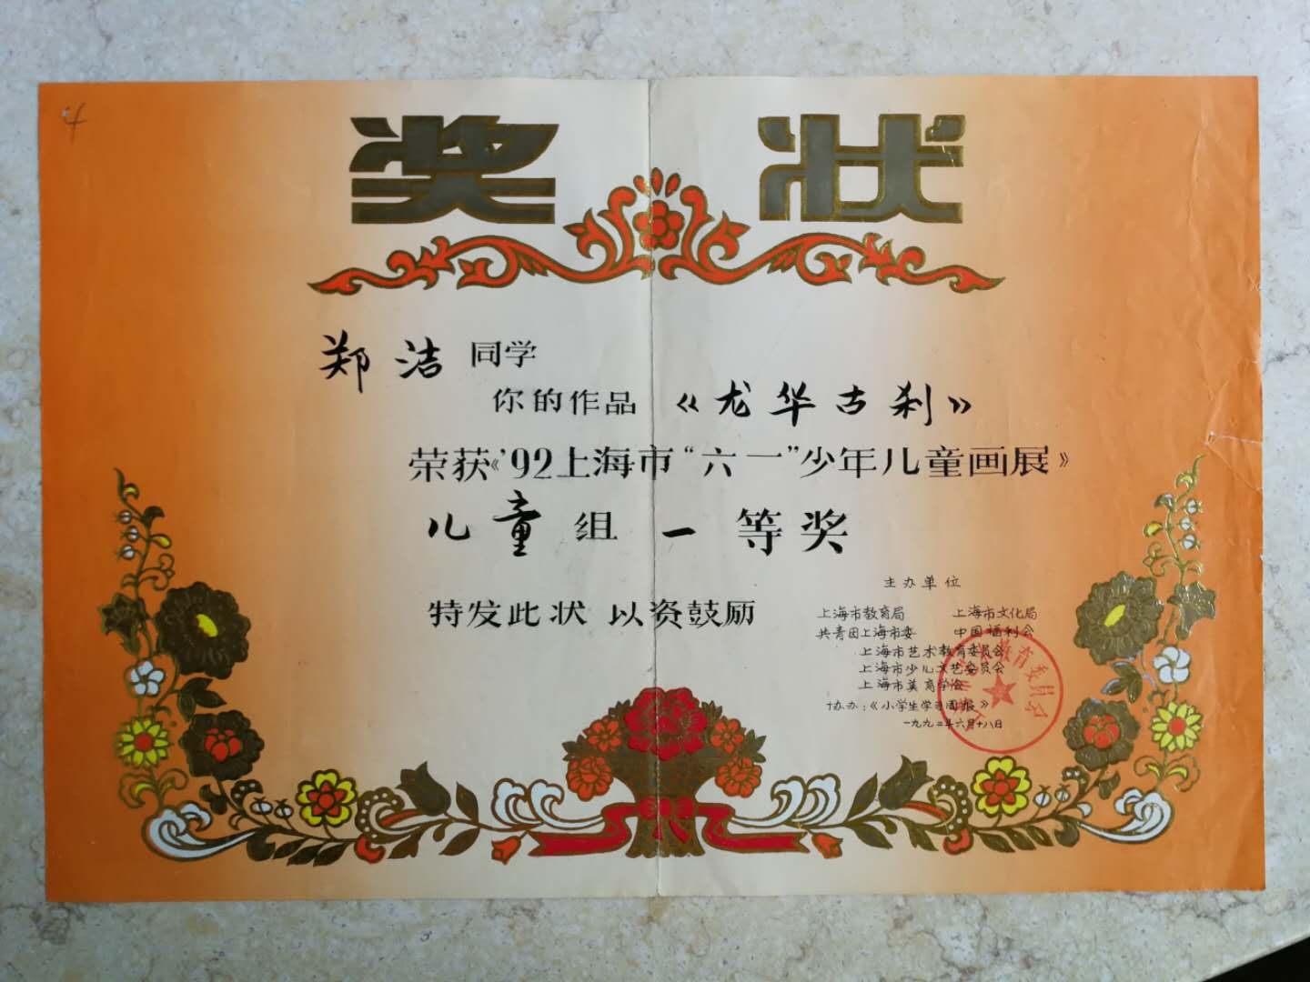

|  |  |
| --- | --- |
| 1992 | First Prize in the June 1st Juniors’ Art Contest Festival, Shanghai. |

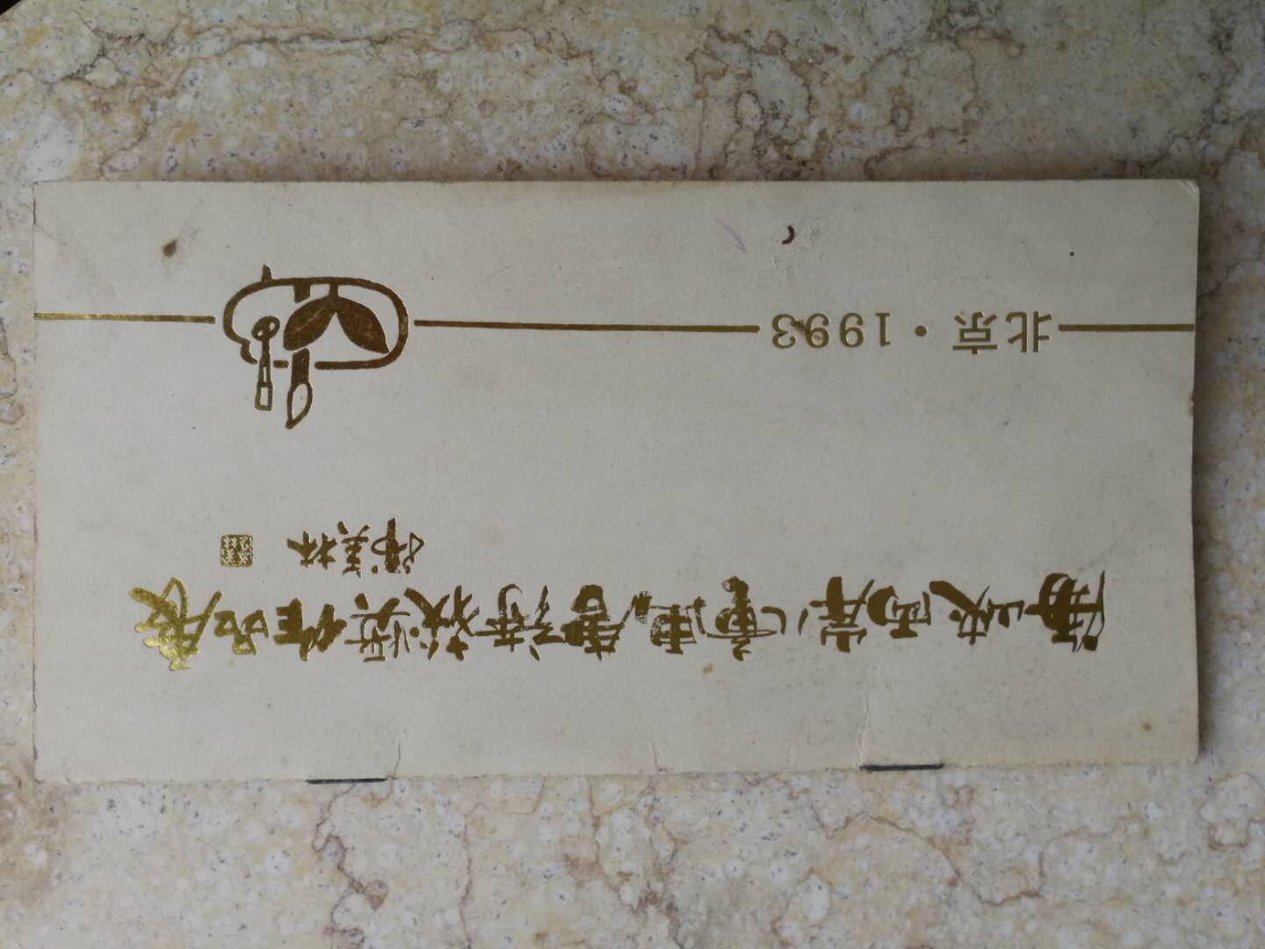

|  |  |
| --- | --- |
| 1993 | Excellence Award in the “Painting Tang-period Poetry: Peking International Junior Art Exhibition across the Straits, Beijing |

|  |  |
| --- | --- |
| 1993 | Encouragement Prize in the Coca Cola Juniors’ Art Exhibit, Shanghai |

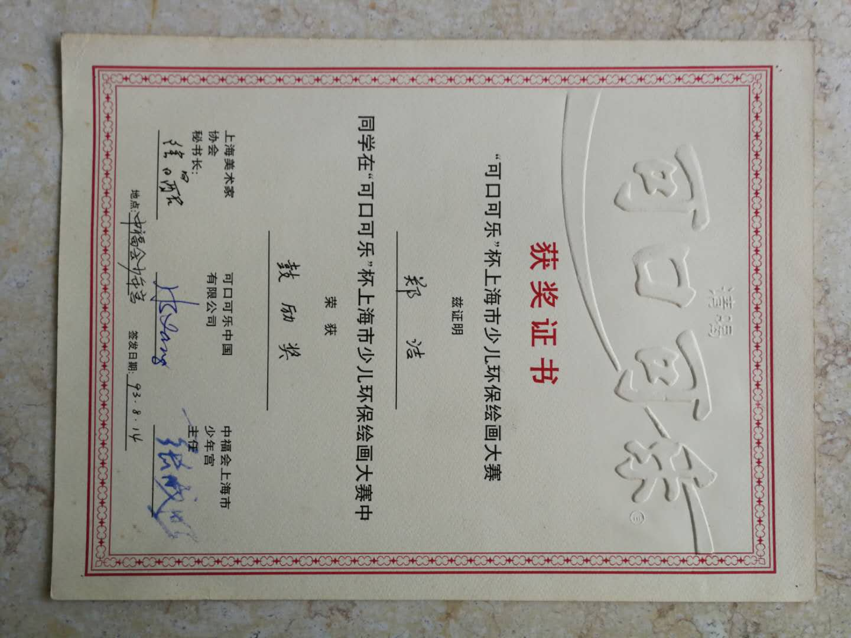

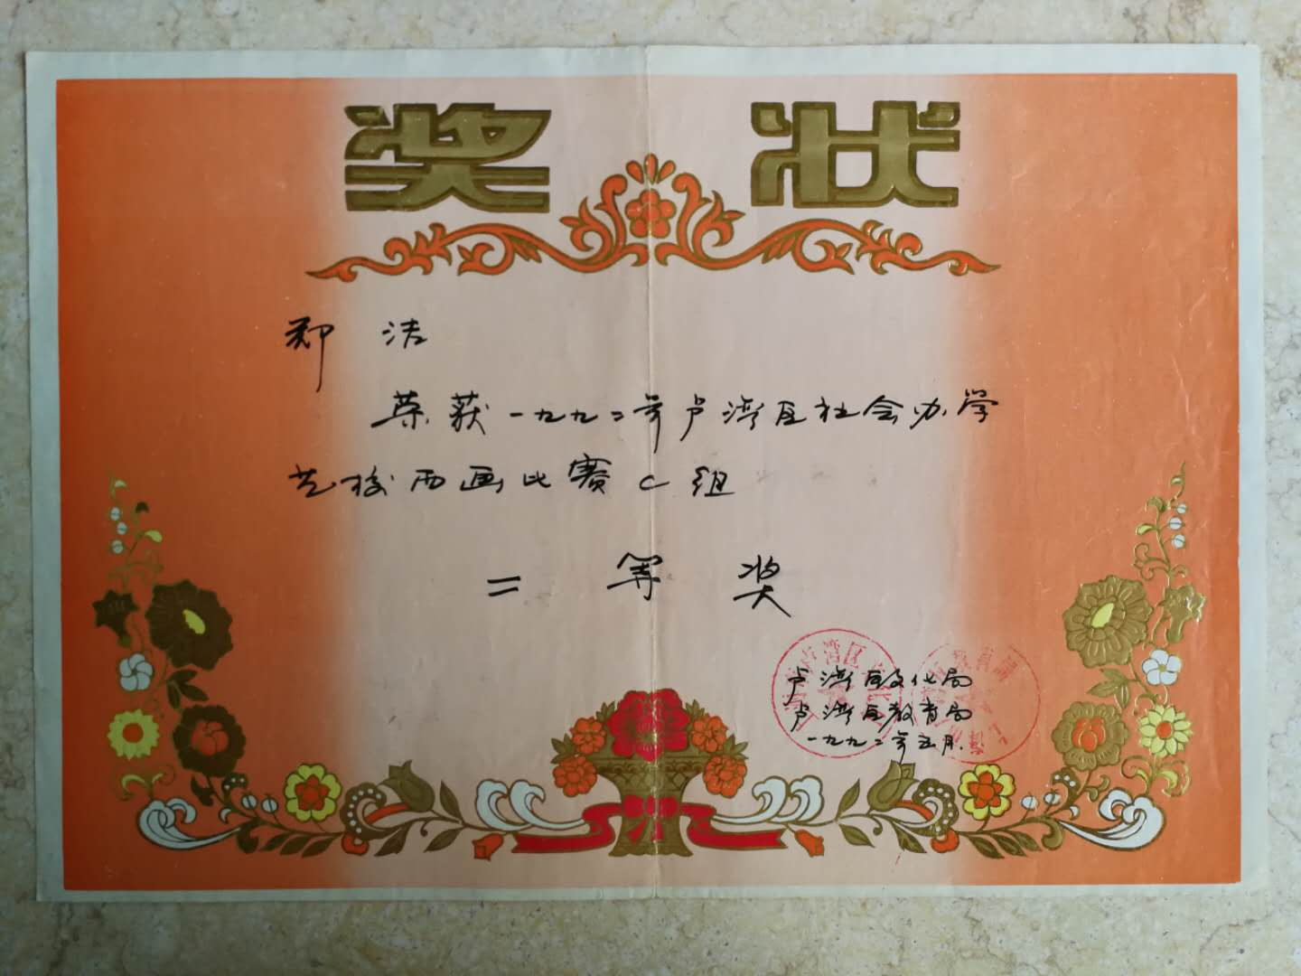

|  |  |
| --- | --- |
| 1992 | Second Prize in the Luwan District Non-governmental Education Painting Contest, Shanghai. |

|  |  |
| --- | --- |
| 1992 | Excellent Painting Award in the Beijing International Juniors’ Art Contest, Beijing. |

|  |  |
| --- | --- |
| 1992 | Third Prize in the Tianbao Art Exhibit, Shanghai. |

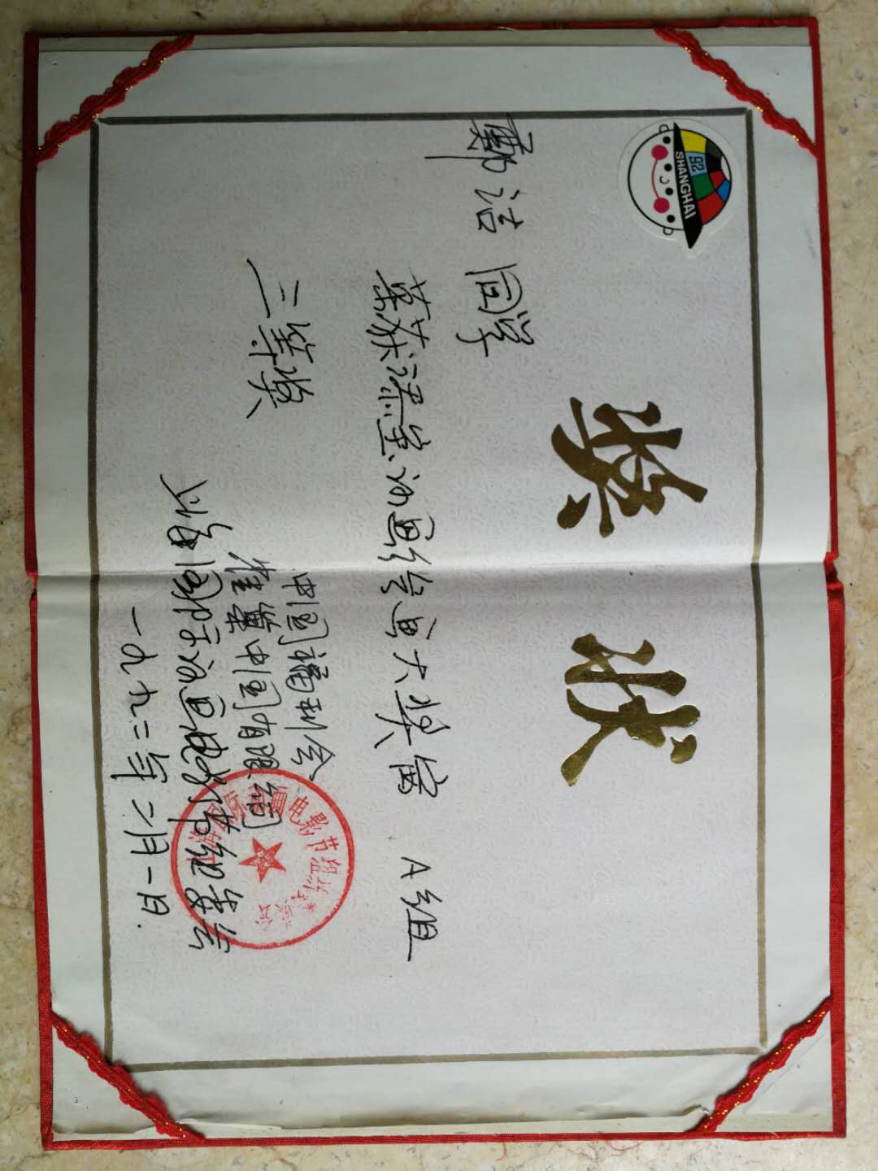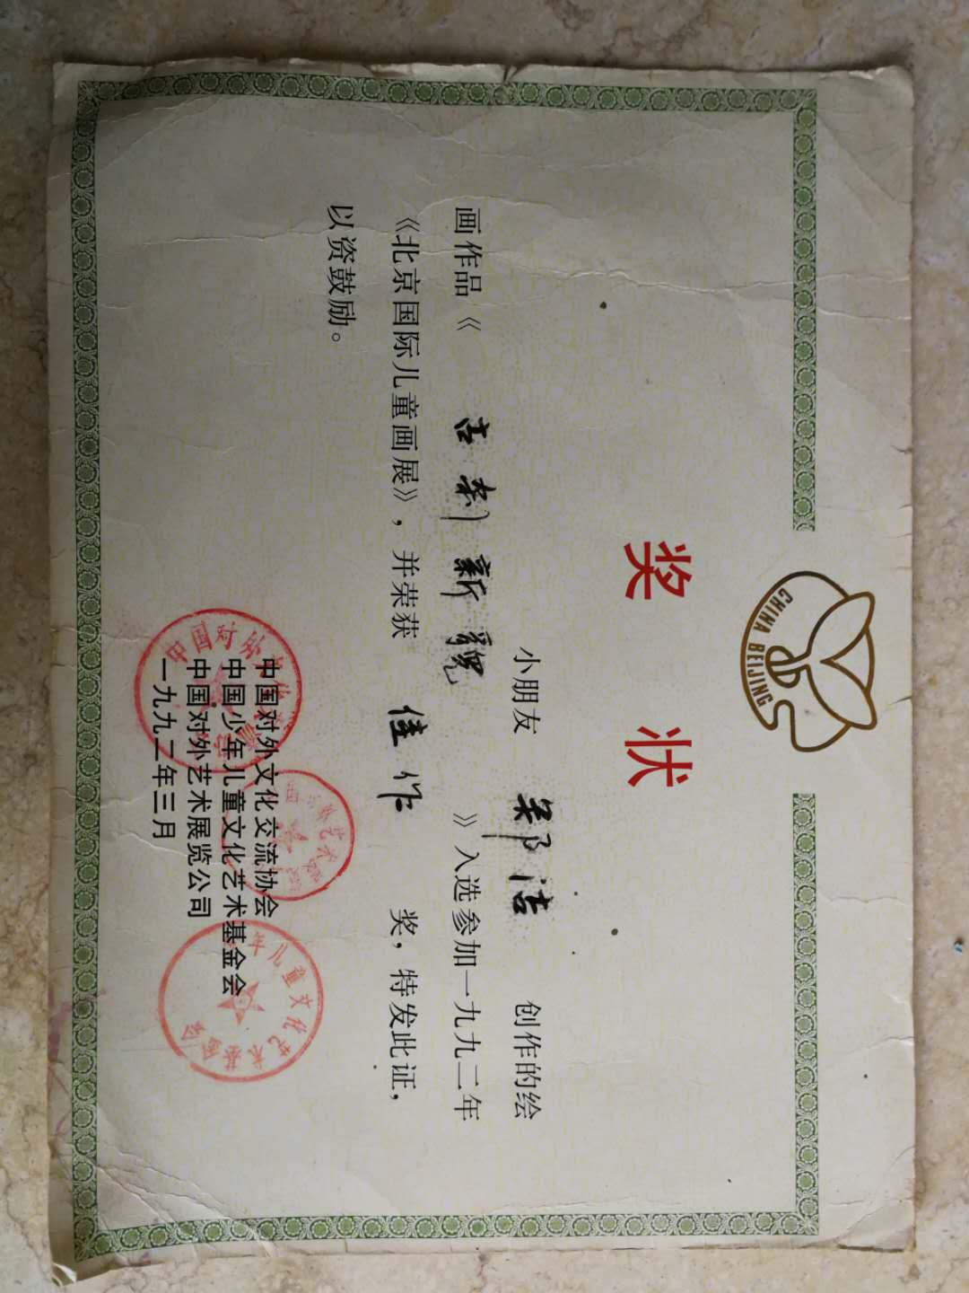

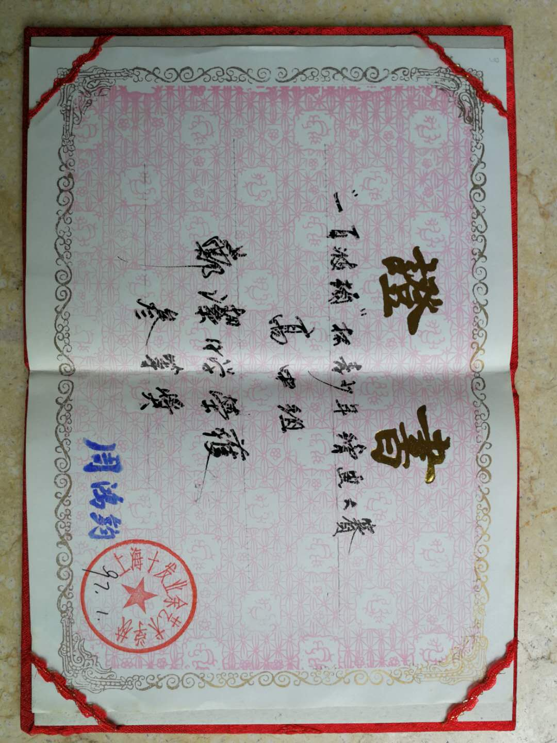

|  |  |
| --- | --- |
| 1997 | Third Prize in the Bolton Cub Painting Contest (High School Group), Shanghai |

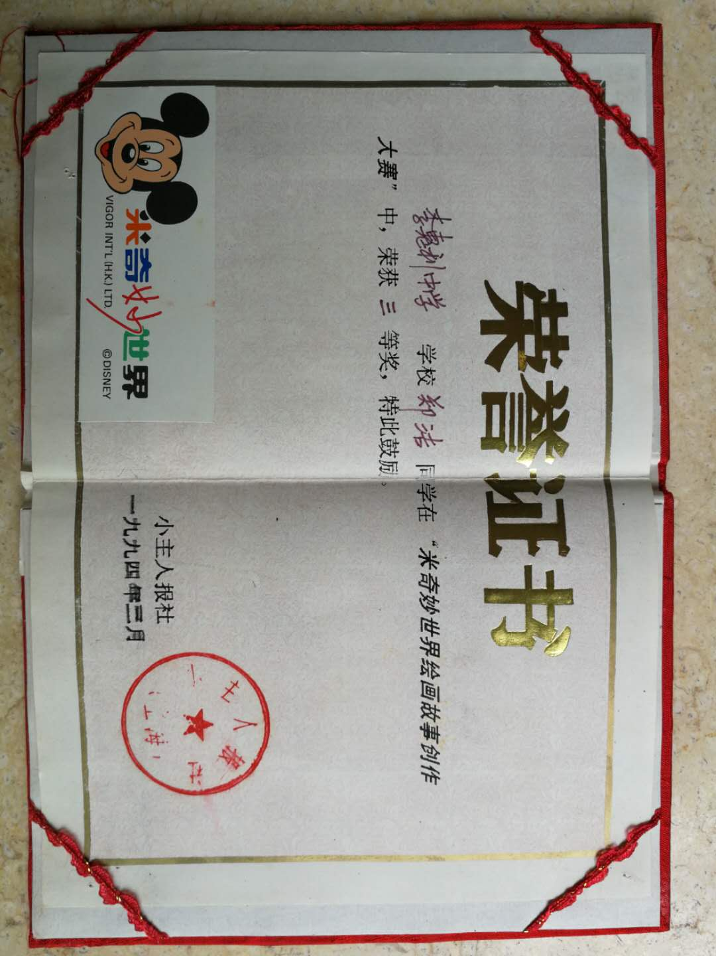

|  |  |
| --- | --- |
| 1994 | Third Prize in the Mickey Painting Contest, Shanghai. |

|  |  |
| --- | --- |
| 1991 | Third Prize in the Luwan District Students’ Art Contest, Shanghai. |

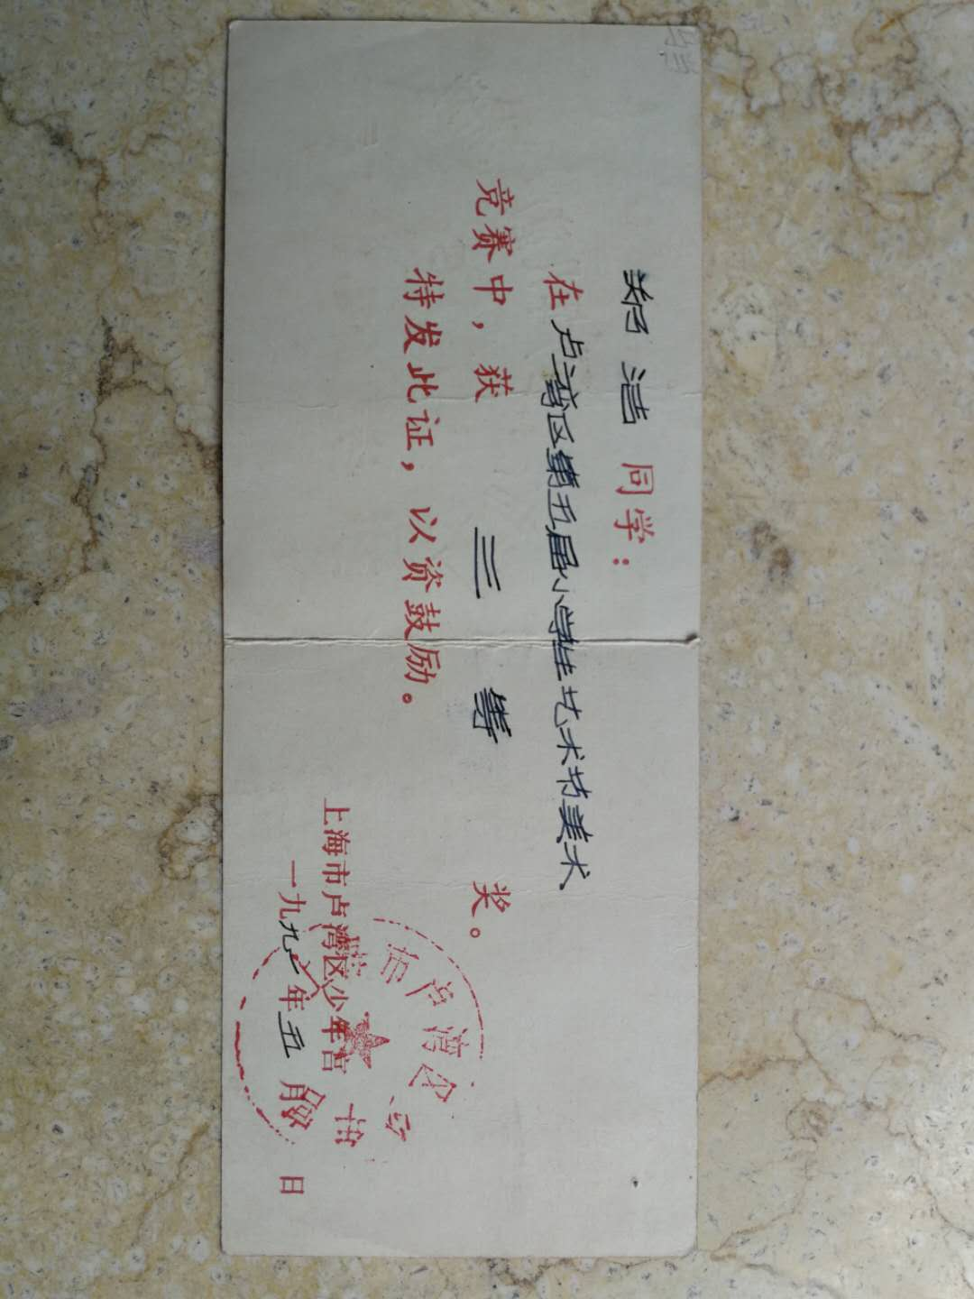

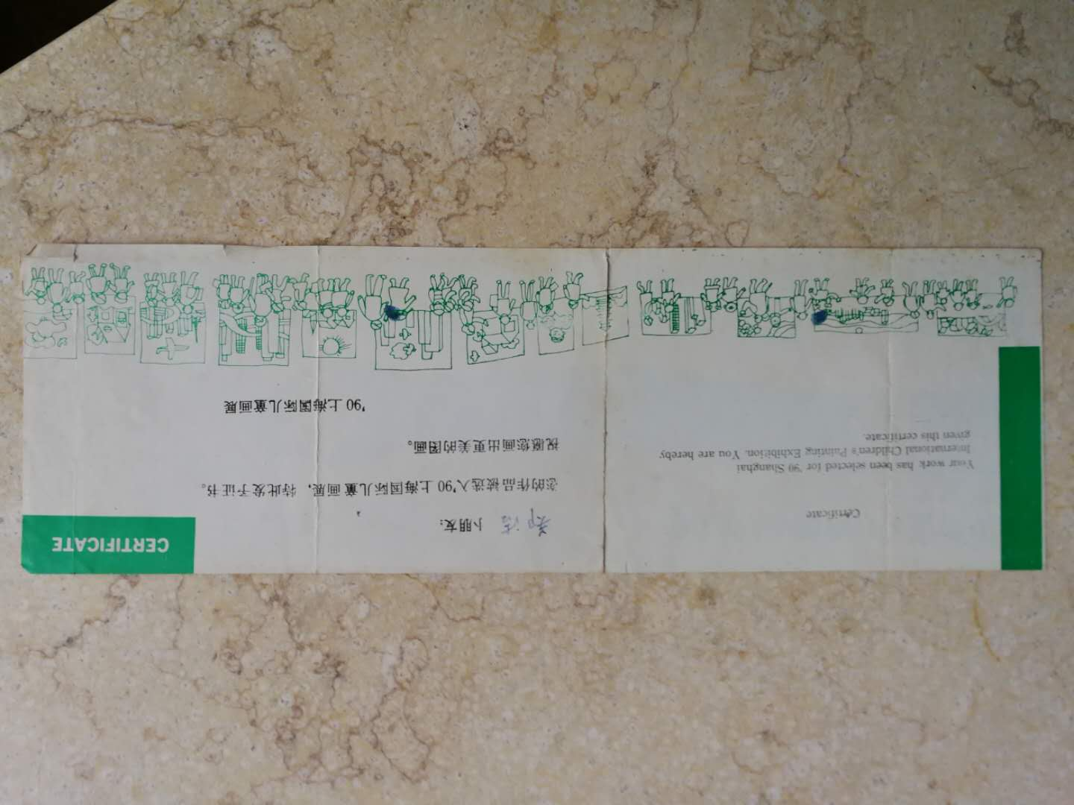

|  |  |
| --- | --- |
| 1990 | Exhibited in the “1990 Shanghai International Children’s Painting Exhibit,” Shanghai. |

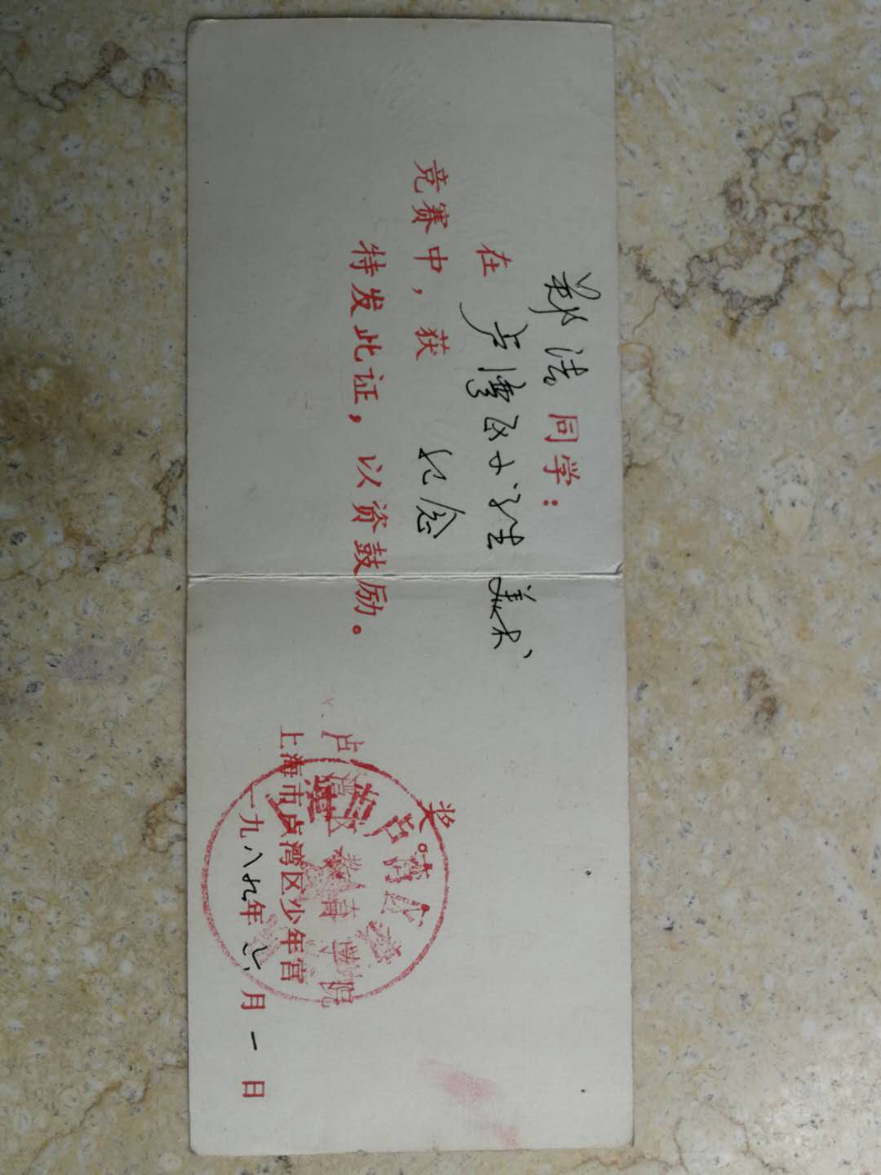

|  |  |
| --- | --- |
| 1989 | Memorial Prize in the Luwan District Students’ Art Contest, Shanghai. |

|  |  |
| --- | --- |
| 1992 | Second Prize in the Luwan – Huangpu – Xuhui – Changning Four District Painting Contest, Shanghai. |

